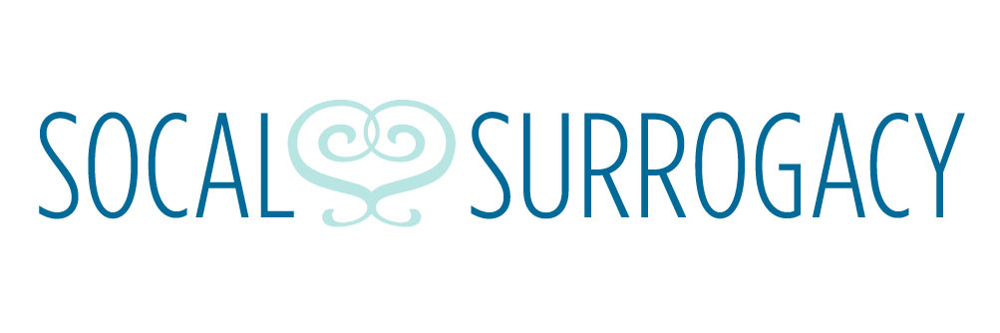
Privacy Policy Statement
This is for the website of www.socal-surrogacy.com
Our address is:
13011 Newport Ave. Suite 207 Tustin, CA. 92780

Please feel free to reach us via e-mail office@socal-surrogacy.com or reach us by phone
at 714-599-7875

We collect information from you when you register to our site or fill out a form.

When registering to our site, you may be asked to enter your: name, e-mail address, mailing address, phone number.

Your information, whether public or private, will not be sold, transferred, exchanged or given to any other company for any reason whatsoever, without your consent, other than for the purpose of this process. The email address you provide may be used to send you information, respond to inquiries, and/or other requests or questions.

We implement a variety of security measures to maintain the safety of your personal information when you enter or submit your personal information.

We do not sell, trade, or transfer identifiable information to outside parties. This does not include trusted third parties who assist us in conducting our business, servicing you, or operating our website so long as those parties agree to keep this information confidential. We may also release your information when we believe release is appropriate to comply with the law, enforce our site policies, or protect others or our rights, property, or safety.

Occasionally, at our discretion, we may include or offer third party services on our website. These third party sites have separate and independent privacy policies. We therefore have no responsibility or liability for the content and activities of these linked sites. In addition, since we have no control over the privacy practice of linked external internet websites you should read and understand the policies of all linked external websites with respect to their privacy practices.

If you feel that this site is not following its stated information policy, you may contact us at the above addresses or phone number.

By using our site, you consent to our online privacy policy.

